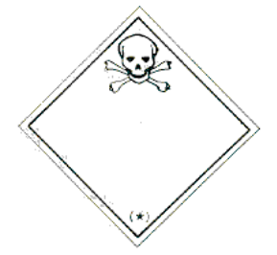



*(NAMA PTj)*

*NOMBOR BEKAS*

*(DIISI OLEH JA/ PENYELARAS SISA)*

**\*TARIKH SISA DIHASILKAN : __________________**

*(DATE GENERATED)*

*(HANTAR KE STOR SISA PTj)*

**TARIKH LUPUS : ____________________________**

*(DATE DISPOSED)*

**\*BILIK/MAKMAL: ___________________________________________________**

*(ROOM/LABORATORY)*

**JABATAN/UNIT : __________________________________________________**

*(DEPARTMENT/UNIT)*

**\*PEGAWAI BERTANGGUNGJAWAB : _________________________________**

*(PERSON INCHARGED)*

**\*NO. TEL (PEJABAT/BIMBIT): ________________________________________**

*(TELEPHONE NUMBER)*

**SW109: *USED LIGHT/TUBE***

(LAMPU/MENTOL TERPAKAI YANG MENGANDUNGI RAKSA ATAU SEBATIANNYA/*WASTE CONTAINING MERCURY OR ITS COMPOUND*)

*TOXIC SUBSTANCES (WASTE)*

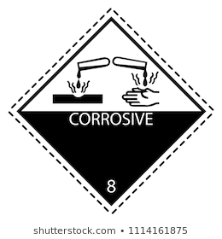

*CORROSIVE SUBSTANCES*

*(WASTE)*

**SW301: SPENT ORGANIC ACIDS**

(ASID ORGANIK TERPAKAI DENGAN pH KURANG DARI DUA (2) /

*SPENT ORGANIC ACIDS WITH pH LESS OR EQUAL TO TWO(2*)



*(NAMA PTj)*

*NOMBOR BEKAS*

*(DIISI OLEH JA/ PENYELARAS SISA)*

**\*TARIKH SISA DIHASILKAN : __________________**

*(DATE GENERATED)*

*(HANTAR KE STOR SISA PTj)*

**TARIKH LUPUS : ____________________________**

*(DATE DISPOSED)*

**\*BILIK/MAKMAL: ___________________________________________________**

*(ROOM/LABORATORY)*

**JABATAN/UNIT : __________________________________________________**

*(DEPARTMENT/UNIT)*

**\*PEGAWAI BERTANGGUNGJAWAB : _________________________________**

*(PERSON INCHARGED)*

**\*NO. TEL (PEJABAT/BIMBIT): ________________________________________**

*(TELEPHONE NUMBER)*

*TOXIC SUBSTANCES*

*(WASTE)*